**Lusine Sahakyan**

37 Davtashen 4th district, apt. 39

Postal code – 0054

[lusine_sahakyan72@mail.ru](mailto:lusine_sahakyan72@mail.ru)

**KOMITAS VARDAPET AND ARMENIAN SCHOOL OF COMPOSERS**[1]

**Komitas Vardapet - the Armenian Music Giant**

**Abstract**: The article studies the role and significance of Komitas Vardapet's composing mission in the context of Armenian and world musical culture. For the first time, the creative standpoints and theoretical provisions of composer Komitas have been studied comprehensively. Komitas's creative principles underlying the formation of national composer thinking and style are outlined. The works of composers of post - Komitas period based on Komitas's works in terms of theme or content are compiled in the article.

Komitas Vardapet is one of the exceptional phenomena of Armenian musical art. A musician who carried out various activities (he was a composer, musicologist, folklorist, singer, conductor and educator), thus confirming the existence of Armenian independent music. Many people view Komitas primarily as a musicologist, scientist, theorist, folklorist, who saved and studied thousands of samples of Armenian rustic song. Komitas was known to be an internationally renowned scientist at a young age, who presented the Armenian musical culture to the world. He was one of the founding members of the International Music Society, the only one from Asia. This fact also comes to confirm that Komitas was, first of all, a musicologist.

I can assume that in the thorough analysis of Komitas's musical-theoretical and folkloristic heritage a proper tribute should be paid to Armenian musicologists, folkloreologists and medieval scholars, who made Komitas's musical-theoretical provisions the benchmark for their studies. Moreover, today practically any serious musicological study makes a reference to Komitas's musicological, musical-folkloristic or haza-study legacy.

What is the historical role of Komitas-composer, how is Komitas Vardapet's creative mission evaluated?

Today, the Armenian school of composers is an established reality which was founded in the 19th century with the art of Tigran Chukhajyan[2]. In this reality, "reviewing" Komitas-composer is a necessity, and, of course, impossible to carry out within one study.

In our opinion, the scope of the activity of Komitas-composer is still not fully acknowledged and deeply appreciated. Komitas's creative legacy needs a new and complete coverage, around which there are many assumptions (Shahverdyan 1959)[3].

We highly appreciate the quote of the distinguished connoisseur of Komitas R. Atayan about Komitas Vardapet:

"The centuries-old Armenian spiritual monody, the ancient rustic song, which if passed down orally could have lost its purity, found its powerful protector in the name of Komitas. Komitas Vardapet wrote down the most idiosyncratic and typical Armenian samples in the far off and distant villages, from the priests. Komitas re-interpreted these records, confiding a new artistic refinement to them. The folk song became the character and content basis for Komitas's works. Of all the great composers and Armenian music figures of the end of last century and the beginning of this century Komitas Vardapet was most deeply aware of the importance of folk music in the formation of national school of composers" (Atayan 1969:33).

During his lecture "in a workshop hall" in Constantinople, in 1910, Komitas Vardapet advised the audience which appreciated music to quit the disregard for the rustic music, to use it and "to dismiss the weak and defiant music that had such a horrible effect" (Temple 1910:698).

Komitas did not ignore the folk song; moreover he deeply grasped the ideological-imagery depth of the latter, its thematic and constitutive components, mode and intonation, meter and rhythmic riches. Komitas discovered exclusive artistic merits in the centuries-old folklore heritage of the Armenian people. Vardapet developed a new principle; he turned to national roots, melodies, and spiritual music. Being one of the greatest connoisseurs of Armenian folk and spiritual music, Komitas Vardapet began his career as a composer with the deep perceptions of the merits of the Armenian rustic and spiritual song, and as he claimed, "Folk music gives birth to spiritual music" (Byzantion 1912:1).

Komitas turned rustic oral musical art into a written one - notation, musical text, musical-linguistic dictionary[4]. This was one of the first important starting points for composers.

It is known that "writing down", re-interpreting folklore was not a new discovery in the art of composing. The "folklore" discovered by Komitas was a discovery for the Armenian art of composing, and his works based on rustic songs are unsurpassed works of art based on national traditions and crystallized by the contemporary art of composing (Zurabyan 2014).

"The deeper the folklore is perceived by the composer, the deeper and the more significantly it fertilizes his creativity”, writes ethno musicologist I. Zemtsovsky (Zemtsovsky 1978:18).

First, we must clarify how the concepts "composer" and "school of composers" are related to Komitas Vardapet's activities.

According to the musical dictionaries the term school of composers is defined as a direction, system, experience, and style of art. "Composer" is a term, a concept, as well as a profession. In the 10th -11th centuries, in the Middle Ages composing was defined as the ability of creating a polyphonic choral. In the 15th century, Johannes Tinctoris defined composing as the ability of writing a cantus, in the 16th century Heinrich Glarean used the term composer to define those who composed polyphonic works of art. Since the 19th century, a composer was also considered a profession in Europe. The profession of a composer implied the ability to create music, the knowledge of composing techniques, etc. The development of notation played an important role for creating a musical composition (Rebatet 1979։53)[5].

The art of Komitas Vardapet can certainly be linked to both the church and the spiritual song, as well as to the skill of creating polyphonic music and to the development of European notation.

But in Armenian music, the limits of Komitas's art of composing are beyond the definitions found in dictionaries, and are associated with such notions as national musical thinking, new art style, the concept of composing, creative principles, and the establishment of national school (Khudabashyan 1981:5-15, Navoyan 2017:90-120).

We do not seek to present biographical facts about Komitas Vardapet in detail. Komitas was a celibate teacher, who lived and worked in Armenian churches, studied Armenian spiritual music, poetry and haza system, as he himself put it, "Spiritual, pure and simple Armenian chant music." It is undeniable that Komitas Vardapet, being a clergyman, could not be called a composer by European standards and definitions. It should be mentioned, however, that Komitas studied in Germany and knew the constructive idea of ​​German music, and during his mature creative period he had deeply grasped the colorful thinking of French art.

These two components are present in Komitas's music on the basis of national mode, harmony, rhythm and intonation. Komitas knew not only Armenian music folklore and medieval spiritual monody, but also world classical music. Komitas was gifted with the composer's exceptional talent, composer's inspiration and intuition, with the ability of self-education and self-development.

Unfortunately, only foreign musicians and those of Armenian intellectuals who had ties to European music culture appreciated Komitas during his lifetime as an innovator-creator of European standards, as the pinnacle of the national school of composers (Sahakyan 2016: 242-263, Sahakyan 2017:81-89)[6].

Komitas Vardapet's "spiritual brothers" perceived him as a teacher of the church and did not accept his so-called "secular" activities, they did not accept him to be a composer by European standards. The fact that Komitas was a composer was beyond their usual perceptions.

Moreover, the clergy who banned concerts in Constantinople claimed that Vardapet did not have the right to rise on the stage of the theater, which could "upset the rules of the sacrament ... according to the Laws of the Apostolic Church any ordinance or singing performed on the theatrical stage was considered sacrilege" (Byzantion 1910:151).

Komitas Vardapet, being an extremely honest person, did not even call himself a "composer", considering his works as "harmonizings."[7] Komitas wrote on the cover pages of his collections published in Paris in 1907 and in Leipzig in 1912, "Armenian lyric rustic songs: Collected, harmonized by Komitas Vardapet"; in French "Collecting and harmonizing" is translated Transcrites et harmonisées, and in the Leipzig edition it is written "Written and harmonized by Komitas Vardapet", in German - Gesammeltnd harmonisiert. It is necessary to "grasp" the words of Komitas Vardapet first in Armenian, then in foreign languages, moreover, foreign language formulations were aimed at being comprehensible to the European listener. Komitas's publications done at his own expenses were adequately appreciated in Europe (Byzantion 1911:2)[8]. With those "harmonizings" Komitas, as if wanted to praise his own people, showing its powerful creative force.

Komitas wrote "We took care of those harmonizings in order to keep the style and spirit of the Armenian rural patterns, which have an independent character and are pure national stamp bearers” (Komitas 1907:3).

This motto of Komitas became the benchmark of creating Armenian school of composers. His "secular" activity was appreciated by progressive composers of the time who did not consider Komitas's works as "processings" by the accepted term[9]. Moreover, during his lifetime Komitas was compared to Liszt, Debussy, Glinka, Rimsky-Korsakov, Mussorgsky, Grieg, who discovered the origins of folk music and used it in their works (Azatamart 1913:1).

Komitas's works are not "processings", but masterpieces of composing perfection, and Komitas left a vast heritage to the future Armenian composers in the genre of "processing". In our deepest conviction Komitas's works are not subject to any change, like Josquin des Prez's masterpieces of choral polyphony, which are based on folk songs and which have never been regarded as "processings"(Mansourian 1969)[10].

The significance of composer Komitas (as well as ethnographer) during his lifetime already surpassed the boundaries of the Armenian reality. As it was typical for the greatest musicians of the 20th century, Komitas discovered, scientifically substantiated and practically re-interpreted an entire theory on national modes, he revised the musical-constructive principles, which had different manifestations in the Armenian art of composing; Komitas's traditions fertilized an entire school of composers. Composer Komitas's heritage became the sum total of his multifaceted activities.

In a short essay written to the memory of Komitas in 1900, the great Armenian composer Nikoghayos Tigranian, a graduate of Vienna's musical institute, highlighting the "color and pace of the polyphonic form" of Komitas's works praised his polyphonic art considering him the founder of the polyphonic form in Armenian art of composing (Komitas 1930:90).

The founder of the Armenian romance, composer, music and public figure Romanos Melikian, who was educated in Moscow and St. Petersburg, did not refer to Komitas in any essay but he enthusiastically organized concerts, during which Komitas's works were performed. Romanos Melikian also actively participated in the publication of Komitas's collections, appreciating their christomatic significance (Melikyan 1977:127).

Getting acquainted with Komitas's works the founder of Armenian symphonic music Alexander Spendiaryan, who had studied in Moscow and St. Petersburg, said, "I discovered the greatest Armenian composer who will be among my teachers from now on" (Shahverdyan 1957:32).

The founder of the Armenian New School of Composers Aram Khachaturian wrote, "I think every Armenian musician should consider his sacred duty to develop Komitas's contributions, contributions which Komitas committed to us with his works ... Komitas has been, is, and will remain my greatest teacher" (Khachaturian 1969:1-2).

Listing the relationships between Komitas and Armenian composers would mean listing almost all the Armenian composers of post-Komitas period.

In 1950s, Armenian writer, musicologist Hakob Asaturyan wrote, "The mastery of Komitas's art has opened a door for rational debates. It is probably Komitas's fault, if there is any. He is published everywhere, and it is either part of church music or folk music. Apparently, Vardapet was far from worrying about publishing his personal works, working always to the detriment of his ego; first and foremost dealing with the folk song and a thousand and one problems lined to it" (Asaturyan 1957:416-418)[11].

Though Komitas did not have a European orchestra with a wide range of opportunities at his disposal, he solved a number of problems with his "modest" staff of performers. With vocal, chamber and piano pieces Komitas discovered the main features of national musical thinking and the creative principles with which the Armenian school of composers is developing even today. Komitas's piano dances are exceptional pieces of music in their artistic value, revealing the layers of Armenian ancient musical thinking, at the same time being in line with the innovative trends of instrumental music. Komitas's dances can be a separate and serious study material even today (Atayan 1982:14).

Komitas united his own mentality of a composer with the collective genius of national mentality and the achievements of world music. With his works he confirmed the existence of Armenian independent music.

Komitas-composer's musical thinking is so intertwined with folk song that often an impression is created that Komitas Vardapet was one of the medieval musician-poets who composed treasures of verses, or the rustic-singer who suddenly united with the nature's laws to create his song. In Komitas's case not only was the oral tradition turned into writing, but also the artistic thinking of the people who came from the depths of centuries was revived. In Komitas's works the Armenian song was reborn in its original beauty. We consider it appropriate to refer to Hovhannes Tumanyan's creative heritage, where it is difficult to say where folklore ends and the poet's creation is born; they are united and perfectly harmonious.

Uniting the achievements of Armenian and world music Armenian composers continued and modernized the traditions of Komitas[12].

As we have already mentioned, Komitas's compositional-constructive principles had different manifestations in the Armenian National School of Composers.

1) Komitas's modal mentality is one of the foundations of national identity of the art of composing. Armenian melodies created on the basis of national modes have a distinctive structure and sound, and in this they differ from the music of other nations. Komitas Vardapet discovered and used, to the extent possible, the richness and beauty of Armenian melodies based on national modes. The features of Komitas's harmonious and polyphonic writing styles, polymodal, polytonic combinations, as well as original quart-quintaccord sounds deriving from modes are structured in Armenian modes (Stepanyan 1969։121).

All the components of Komitas's musical language (harmony, metrics, or as he defined the "accent and tact", accentual law[13]) are derived from the peculiarities of folk music. The national musical patterns are reinterpreted in the art of Komitas with an exceptional skill, with the constructive talent typical to the 20th century art of composing, in line with the trends of impressionism or avant-garde music.

Komitas created a unique musical texture where every detail is highlighted - from sound transparency to the pedal tone [14].

It was the classical clarity and perfection of the texture to which the greatest musicians of the 20th century sought to reach, and there is no doubt that the art of Komitas is also one of the 20th century's innovative phenomena (Geodakyan 1969: 54-121).

2) The unique polyphonic style of Komitas was the most important discovery and achievement for the establishment of the Armenian National School of Composers. Polyphony was not only a way of thinking for Komitas, but also an important means of musical expression, built on the basis of the patterns of the national modes and monody features, with emphasized independent voices. Komitas's a capella chorals are distinguished by the diversity of sound texture, from choral-harmonic chords to the perfect samples of infrasound-imitation polyphony (Bagdasaryan 1990).

A perfect example of Komitas Vardapet's choral polyphony is the Divine Liturgy (Komitas 1997)[15].

The polyphonic texture of Komitas's voluminous work - the meaning of "melodic polyphony"[16], the national uniqueness of choral polyphony - is unique in Armenian art of composing (in particular for the formation of cantata-oratorio genres) [17].

As musicologist G. Chebotaryan correctly noted, "Only Komitas was able to find the key to the correct disclosure of the harmonious Armenian folk song happily combining the talented composer, the great ethnographer and theorist in himself. Only Komitas was able to use the classical tricks of polyphonic art in the Armenian music with such a breakthrough that the Armenian folk song not only preserved national identity, but, on the contrary, manifested it more vividly. By thoroughly studying the Armenian songmaking, coming out of the modal-intonation features of the Armenian song and the polyphonic elements hidden in them, Komitas laid the foundations of polyphony in Armenian music" (Chebotaryan 1963:15-19, Pashinyan 1981:171-199).

3) Komitas attached great importance to lyrics, lyrics-music connection, and lyrics sounding. Komitas revealed the inner affinity of lyrics and melody in the folk songs. He viewed the lyrics and melody as a unity. A single result of a people's creation. Together with melodies of exceptional value, Komitas wrote valuable samples of folk poetry. He insisted, "Language is the pulse of music" (Komitas 2009:176).

Komitas Vardapet was brilliantly fluent in all the literary Armenian branches and dialects. Being gifted with literary talent, Komitas Vardapet wrote poems, was familiar with the peculiarities of writing poetry verses (Komitas 1939).

Komitas Vardapet also was engaged in "philological work", about which it is mentioned in the memoirs of great Armenologist Manuk Abeghyan (Komitas 2009:15).

"One sings the way he thinks, the way he talks. Singing and speaking are a uniform ability; the better a person thinks, the better he will speak, and the better he will sing", said Komitas (Byzantion 1913:1).

The greatest classic's approach to language is one of the most important arguments in Armenian composer thinking, particularly in vocal-classical genres (in the works of H. Stepanyan, T. Mansuryan, A. Satyan, E. Yerkanyan, D. Hajian). It is no coincidence that significant achievements of Armenian art of composing were recorded in vocal and choral genres. The scope of our article does not allow us to fully examine the views of Komitas or the conclusions of honored musicologists towards the Armenian language versification, Armenian dialects, the prosodic and modulation systems of the Armenian language.

Robert Atayan wrote in one of his valuable articles, "It is well known that the lyrics of the folk song are often mixed in a senseless manner. Komitas corrected and completed the lyrics of the songs and processed them in the spirit of folk poetry with poetic professionalism" (Atayan 1949:5)[18].

Conventionally, we can point out the directions that guided Komitas. At the same time, Komitas clearly distinguished the melodies that should be sung or performed, "to sing a song, to play a song", even the melodies that should be "read" (Komitas & Abeghyan1905:99).

Vardapet often considered the music and versification of Armenian melodies, "splitting and stratification, rhyme and stress" as an integral unit (Byzantion 1911:1).

In 1909, in a letter to Catholicos of All Armenians Matthew Izmirlian Komitas Vardapet wrote that Armenian music derived from the four main characteristics of its mother tongue - "tact, melody, sound and spirit" (Komitas 2009:175).

And most importantly - the fact of Armenian independent music was substantiated and proved by Komitas in the following way, "The language and literature of a nation can be transformed and developed, taking an example from other nations, but if it has its unique language and literature it has its own music ... it is true that the sacred renovators of the 5th century gave us also music, which is as native and national, as independent and original as its language and literature, because each nation's music is born and developed from its own melodies. The Armenian language has its own special sounding, therefore it has its corresponding music" (Komitas 1941:49)[19].

In the course of time Komitas-composer's mission also had different perceptions. Armenian musicians (up to now) have so called "simple and complicated" relationships with the Great classic.

By saying simple relationships, we understand the use of Komitas's themes as theme-symbols, quotes, citations, rewritings (Zurabyan 2014:28).

The theme of Komitas Vardapet as a characteristic melody of a vivid national character, can become a basic theme for a voluminous work - a symphony or concerto, can develop on a variational basis or with modern musical tricks. Almost all the representatives of post-Khachaturian school of composers re-interpreted Komitas's themes with traditional academic methods. By modern music criteria in "simple" ties[20].

Complex ties are deeper and multilayered; they can be ideological, psychological, imagary or "disguised".

These "disguised" ties make Komitas's music the most interesting and unique phenomena of contemporary world music culture.

"I love the geniusly acknowledged value of his sounds, their scarcity and significance in the works. For me, the purity of the style of Komitas is an eminent height, and the aspiration to reach that height is cherished" (Mansurian 1969:2).

Mansurian and other contemporary Armenian composers who followed him use more free music-making tricks, forming more "sophisticated" ties with the Great Classic. It is interesting to note that Komitas's theme always remained recognizable, complete and unique no matter to whatever transformations it was subjected.

Komitas Vardapet's "Karoun A" is one of the most striking examples of thorough works, one of the variations of which, by the way, had a chamber instrumental accompaniment (unfortunately it has not been preserved)[21].

This song contains a huge amount of thought and emotion. Thanks to the creative personality of the composer, the folk song has turned into a psychological, dramatic monologue, and as an ideological-deep basis, as a constructive theme, "concentration" typical to contemporary music has had many manifestations in the works of Armenian composers[22].

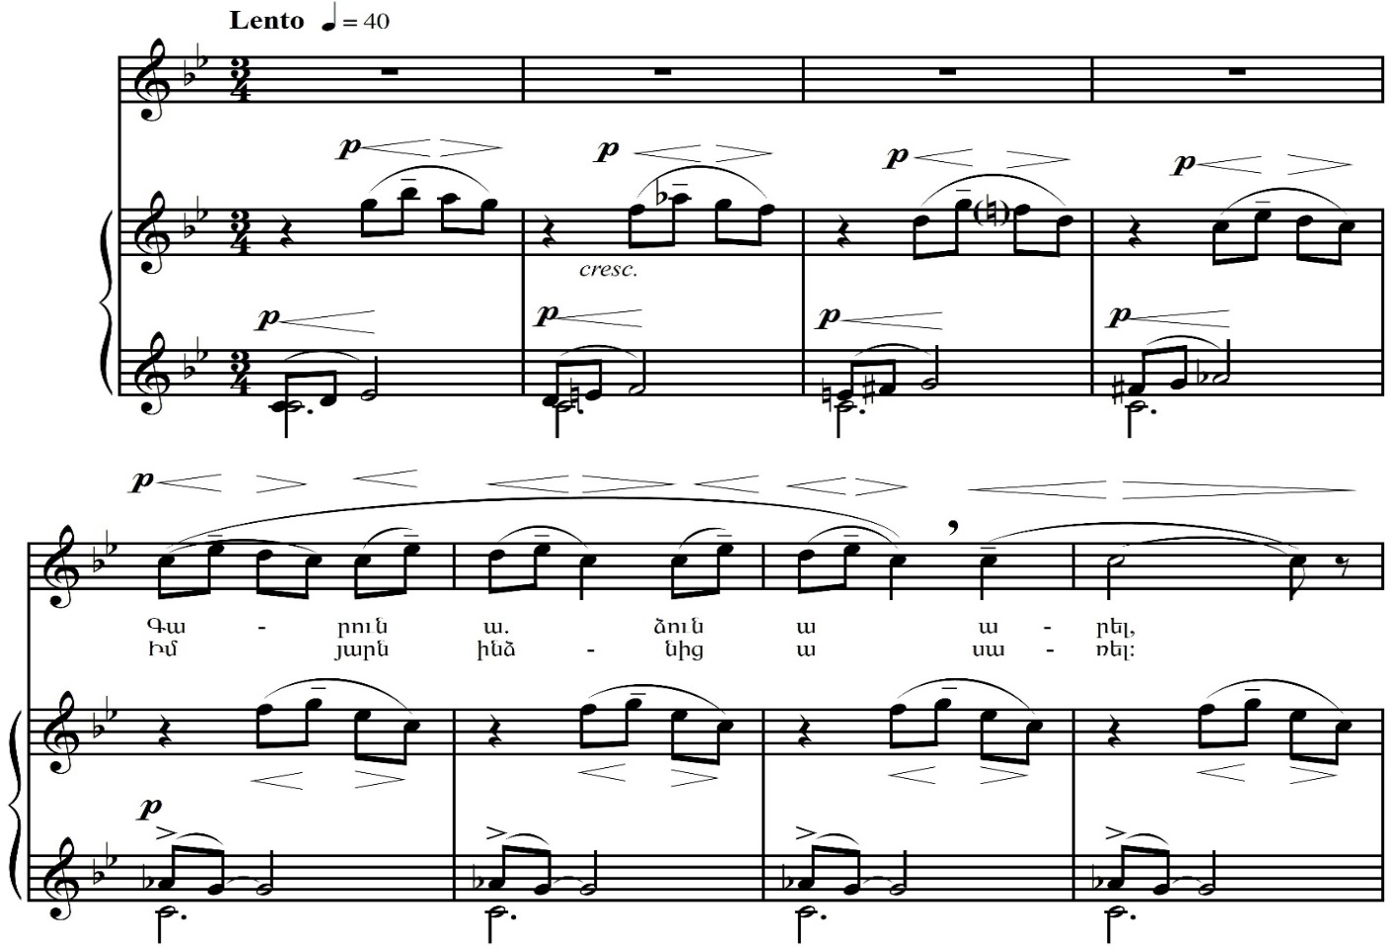

Each sound in Komitas's song "Karoun A" is in its logical movement.

The brief upward motive of the piano accompaniment of the song "Karoun A" lies in the preface of the String Quartet N 2 of great Armenian composer Tigran Mansurian. The Quartet, which is dedicated to the memory of Eduard Khazagotsian, is full of deep psychological emotions. From the preliminary thoughtful motive of Komitas's song Mansurian weaves a unique melody line, which evolves into an extremely tense confession.

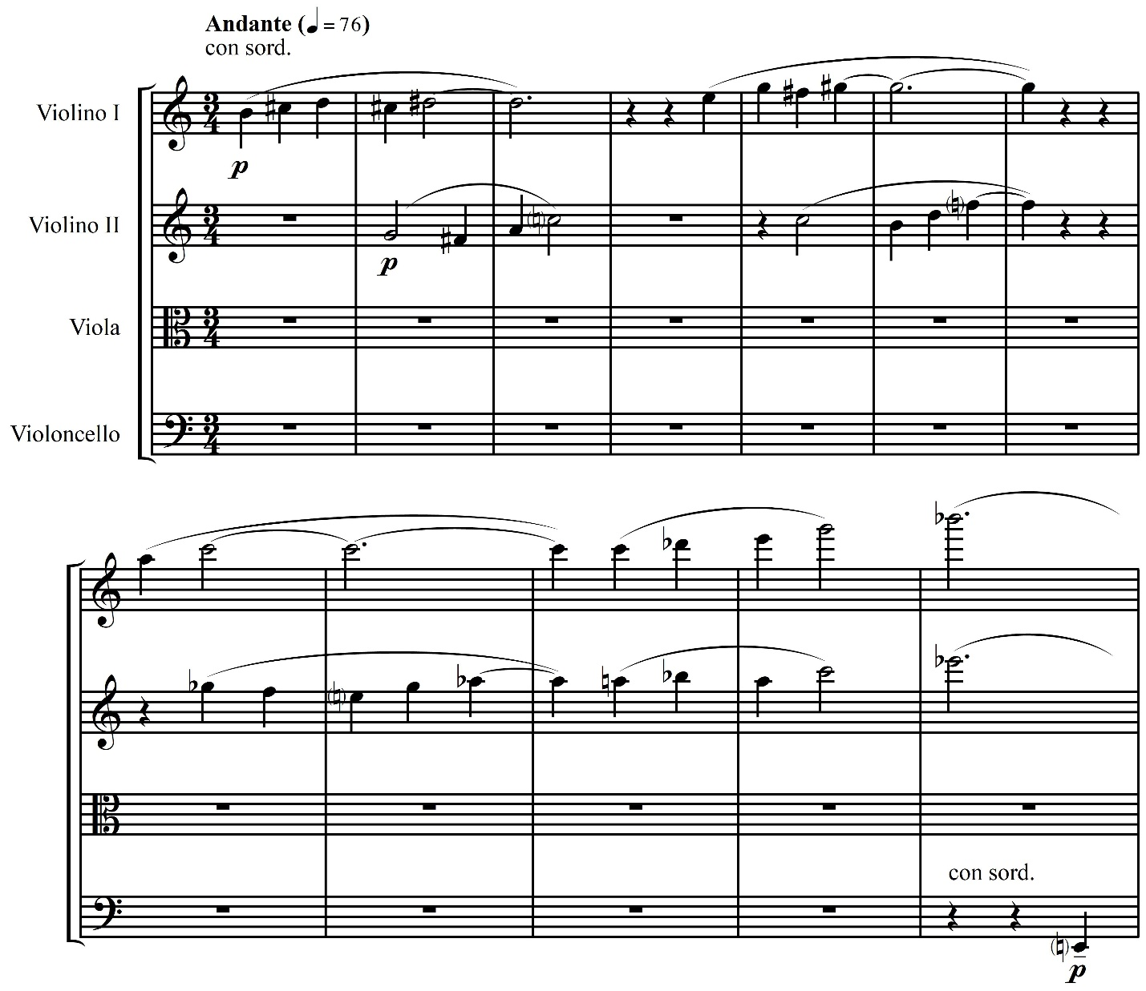

Today, we can state that Komitas Vardapet gave sense to folk music patterns. Armenian school of composers and musical-theoretical thought were anchored on Komitas traditions. He was one of the innovators of the new era, his works are a distinctive phenomenon in both world and Armenian art of composing. The creative principles that were set by Komitas Vardapet are actual even today and will be in the future.

Original and archival materials, newly accumulating facts and memoirs about Komitas Vardapet are more accessible to contemporary Armenian experts on Komitas, which will enable them to analyze Komitas's works in its possible entirety, including ideological-aesthetic, musical-linguistic and compositional-constructive components, as well as "simple and sophisticated ties" with Armenian composers.

Komitas's best commandments to the composer are his own thoughts, given that he himself sought to "the spread of national, inherent, original and delicate art".

Komitas also predicted that, "Folk song will play a great role in paving a straight way for music."

Komitas Vardapet opened that way for us.

**References**

1. Asaturyan, Hakob 1957 “Komitas as a Composer.” *Armenian Citizens* (18): 416-418.
2. Atayan, Robert 1969 “Komitas's Musical Legacy.” *Komitasakan* (1).
3. Atayan, Robert 1949 “The Principle of Folk Song Harmony in Komitas's Works.” *Bulletin*, *ASSR Academy of Sciences*, (9).
4. *Azatamart* 1913 Constantinople (1329):1.
5. Bagdasaryan, Anahit 1990 Imitation Structures in the Works of Komitas (PhD thesis), Yerevan.
6. *Byzantion* 1910 Constantinople (4296):151.
7. *Byzantion* 1911 Constantinople (4386):1.

*Byzantion* 1913 Constantinople (50):1.

1. Chebotaryan, Gayane 1963 “Aram Khachaturian's Polyphonic Thinking.” *Soviet Art* (6):15-19.
2. Geodakyan, Gevorg 1969 “Komitas's Style and the Twentieth Century Music.” *Komitasakan* (1):54-121.
3. Geodakyan, Gevorg 1969 “Komitas and World Music Art.” Jour*nal of the ASSR Academy of Sciences*: 82.
4. Khachaturian, Aram 1969 “The Founder of the Armenian Musical School.” *Soviet Art* (10):1-2.
5. Khudabashyan, Karine 1981 "Komitas and his Predecessors." *Komitasakan* (2): 5-15.
6. Khudabashyan, Karine 2011 “*The Modal Concept of Komitas*.” In Armenian Music in the Light of Comparative Musicology: 21

Komitas Vardapet 1930 Collection of Works, Yerevan.

Komitas Vardapet 1939 Lyric Poetry. Kalata-Istanpul: Culture.

Komitas in the Memoirs and Testimonies of Contemporaries. *Music Series*. Yerevan, 2009:15.

1. Komitas Vardapet 1941 Articles and Studies. Yerevan: State Publishing House.
2. Komitas Vardapet 1982 Collection of Works. (6) ed. by R. Atayan, Yerevan.
3. Komitas Vardapet 2009 Letters. Yerevan: Printinfo.
4. Komitas Vardapet 1997 “Divine Liturgy” *Collection of Works* (7).
5. Komitas Vardapet; Abeghyan, Manuk 1905 A Thousand and One Songs. Folk songbook Second part. Vagharshapat.
6. Komitas Vardapet 1907 Armenian Lyre. Paris.
7. Kushnarev Christophor 1958 Issues on the History and Theory of Armenian Monodic Music. Leningrad: Musical edition.
8. Rebatet, Lucien 1979 Une histoire de lq musique․ Paris։ Robert Laffont․
9. Melikyan, Romanos 1977 Articles, Letters, Memories. Yerevan.
10. Mansurian, Tigran 1969 “Komitas - the Great Renovator.” *Voice of the Homeland.*
11. Navoyan, Mher 2017 “The Concept of National School of Composers by Komitas,” *Etchmiadzin, Official Journal*: 90-120.
12. Pashinyan, Eduard 1981 “On Some Principles of Polyphonic Creativity in Komitas's Chorals.” *Komitasakan* (2):171-199.
13. Sahakyan, Lusine 2016 “Komitas Vardapet and French Culture.” *Kantegh*: 242-263.
14. Sahakyan, Lusine 2017 “Komitas Vardapet and Russian Culture.” *Musical Academy* (2):81-89.
15. Sarkisyan Svetlana 2002 Armenian Music in the Context of the XX Century. Moscow: Composer.
16. Shahverdyan, Alexander 1957 Alexander Spendiaryan. Moscow: Musizd.

Shahverdyan, Alexander 1959 Reviews on the History of Armenian Music. Yerevan: Haypethrat.

1. Stepanyan, Rafael 1969 “Quintaccords and Quartaccords in Komitas's Works.” *Komitasakan* (1):121-147.
2. Tahmazian, Nikoghos 1994 Komitas and the Armenian Musical Heritage. Pasadena, California.

Temple 1910 Constantinople (31):698.

1. Zemtsovsky, Izail 1978 Folklore and the Composer, Theoretical Etudes. Leningrad: Soviet Composer.
2. Zurabyan, Zhanna 2014 Monody in the Armenian Art of Composing. Yerevan: Gitutyun.

**Lusine Sahakyan:** Musicologist, specialist in Komitas studies, pedagogue. PhD in Art History (2007), Associate Professor (since 2009), Head of the Chair of History of Music at Yerevan State Conservatory after Komitas (since 2014). Since 2017 Doctoral student at the National Academy of Sciences of the Republic of Armenia. She is author of the monograph "Komitas Studies in Armenian Musicology", as well as more than 30 articles published in Scopus Scientific Magazine and Review Magazines.

1. This article is part of our extensive work, which studies the role and significance of Komitas Vardapet's composing mission in modern Armenian composer art.  
2. Before that the Armenians had a multi-faceted musical art - spiritual, folk, professional and folk-professional. The Armenian culture was preserved and developed in churches, monasteries, the creators and keepers of which were the fathers of the Armenian Church.
3. In our deepest conviction, the merits of Komitas's works should not be regarded in their number or genre constraint, should not be referred to with the term "cultivate", which was often done in the Soviet period.

    "Byzantion", Constantinople, 1912, N 4743:1.
4. Poets and writers appreciated Komitas as the creator of the letter system of Armenian rustic music, as well as the creator of "alphabet" of Armenian oral music. Paruyr Sevak compared Komitas with Mashtots. Shahan Shahnur and Avetik Isahakyan, Yeghishe Charents and Tumanyan, Derenik Demirchyan and Ghazaros Aghayan admired Komitas's creative art.
5. We did not include some well known facts in the foot notes because they are translated from French by us, and may be of interest to the reader. The word *compositor* translates from Latin as an inventor, composer, creator of music. The etymology and explanation of the word can be found even in school textbooks. See also Musical Encyclopedia 1974: 891.
6. Parisian-Armenian intellectual, writer Arshak Chopanyan, a student at Sorbonne University in Paris Schahan Reteos Berberian, renowned musicologist at Mekhitarist Congregation Father Ghevond Tayan, German medieval writers, Russian composers Mikhail Gnesin and Thomas Hartmann, French artists.
7. By the way, the word "harmonize" is interpreted in Armenian as to melodize, harmonize, adjust sounds, write music, compose. See The Explanatory Dictionary of Modern Armenian Language 1976:468.
8. In 1911, Komitas again planned to travel to Europe "to publish some of his works."
9. Processing or transcription means arrangement, i.e. transition of music from its original version to another instrumental or performance arrangement. In German – Bearbeitung - arrangement, choral arrangement - Choralbearbeitung, English - choral arrangement, French - composition sur choral.
10. We do not deny the fact that over time the genre of processing developed in the art of composing. This topic is discussed in detail in our next article. In connection with Komitas's term "processing" see also Atayan1969: 34.
11. The enthusiastic reception of piano dances in Europe was not accidental. See: Komitas 1982. See also Sarkisyan2002:14.
12. The tendency to combine the traditional and the modern was typical, in general, to the national schools, i.e. the fusion of the national and universal, when the folk song became the thematic basis for European musical genres - symphony, sonata, concerto, quartet and opera.
13. The accentual laws defined by Komitas are a separate topic for study. Komitas's formulations: tact - the duration or size of the vowel or syllable, beat - "beats show only the prosodic unit and the metrical foot", foot - is a rhythmic unit, this is not only the use of Komitas's Armenian musical terms, but also the equivalent definitions of time relationships and rhythmic formulas in modern music.
14. Komitas's piano pieces are a vivid example of this. It was no coincidence that French musicians admired Komitas's dances. With their exceptional artistic significance they also laid the foundations of modern Armenian instrumental music.
15. See also Tahmazian1994:243.
16. See Tahmazian1994:39.
17. Each version of Komitas's Divine Liturgy is a subject of a separate study with its artistic merits.
18. See also Khudabashyan2011:21.
19. See also Byzantion 1911:1.
20. In our work, a comprehensive study material is accumulated, which, of course, will be revised and replenished in the course of time. Komitas's theme, or the number of works created by Komitas's inspiration, is considerable. Edgar Hovhannisyan's First Symphony, where Narekatsi's poem "Havik" (Little Hen) written by Komitas Vardapet is used, the theme of the song "Sona Yar" by Komitas is used in the second part of the same Symphony by Hovhannisyan. Tigran Mansurian in a unique way also touched upon the poem "Havik" (Little Hen) written from Komitas's singing. Grigor Yeghiazaryan, the renowned Armenian composer, also touched upon Komitas's themes, who quoted Komitas's "Kali erg" (The Song of the Threshing Place) in his Symphonic Poem. Levon Astvatsatryan reflected the song "Mokats Mirza" in his Symphony, Emin Aristakesyan reflected Komitas's "Songs of Akna" in his symphony, Jivan Ter-Tadevosyan referred to Komitas's song "Krunk" (The Crane) in his First Symphony, composer Ruben Sargsian used the original motives of the song "Krunk" (The Crane) and "Antuni" in his Symphony and processed Komitas's songs "Hoy Nazan Im" and "Shogher Djan" (My dear Shogher) for string instruments, Aram Satyan processed the song "Chinar es" (You are a poplar tree) by Komitas Vardapet. Composer Vache Sharafyan processed songs such as "Jur Kuga Verin Saren" (Water from the Mountain), "Arnem ertam" (Will take and leave), "Shakhkr-shukhkr", "Es Gisher" (Tonight) by Komitas for the String Orchestra. Composer Mikhail Kokzhaev processed Komitas's songs "Hoy Nazan Im" and "Shogher Djan" (My dear Shogher) for woodwind and string instruments, etc.
21. At the concert in Echmiadzin in 1904, "Karoun A" (It is Spring Time) sounded as a solo for the svirel, the woodwind, 2 violins, the pianette and the piano. See Komitas 1982։224.  
22. E. Mirzoyan in his Quartet, A. Babajanyan in his Piano Trio, E. Hovhannisyan in his Piano Quintet referred to this monumental piece of work. The fundamental differences will be discussed in our further works.